SQL Concepts

**KUNCHALA HARSHA VARDHAN**

# Assuming you are ready with the ER Model (from Morning session Assignment), transform it into a Database schema. Create tables keeping up good practices and send me the create scripts you've written.

* + The script file contains all the creating database, table and inserting queries.

**Table with values:**

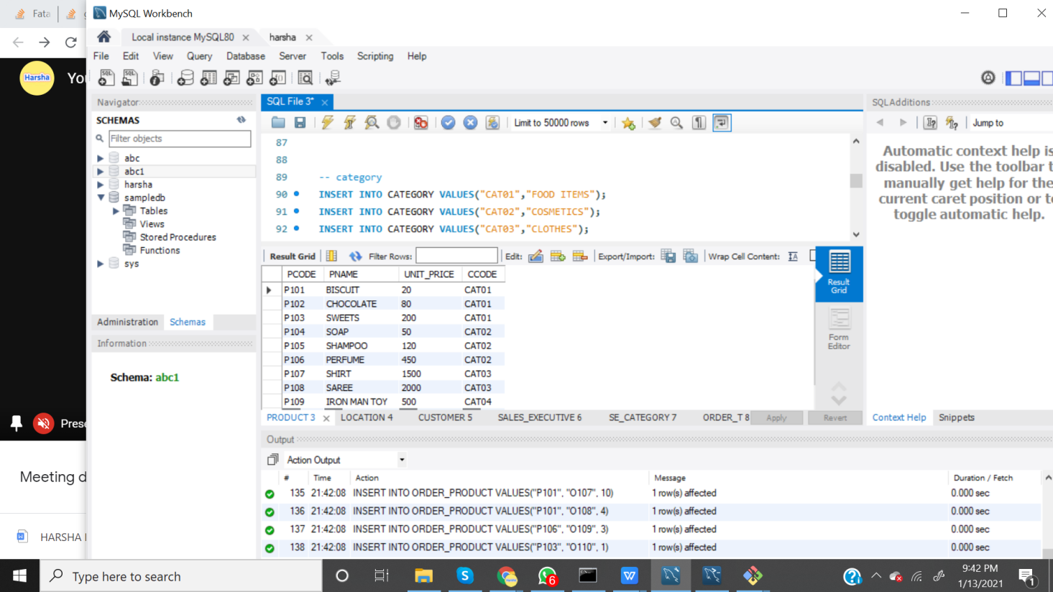

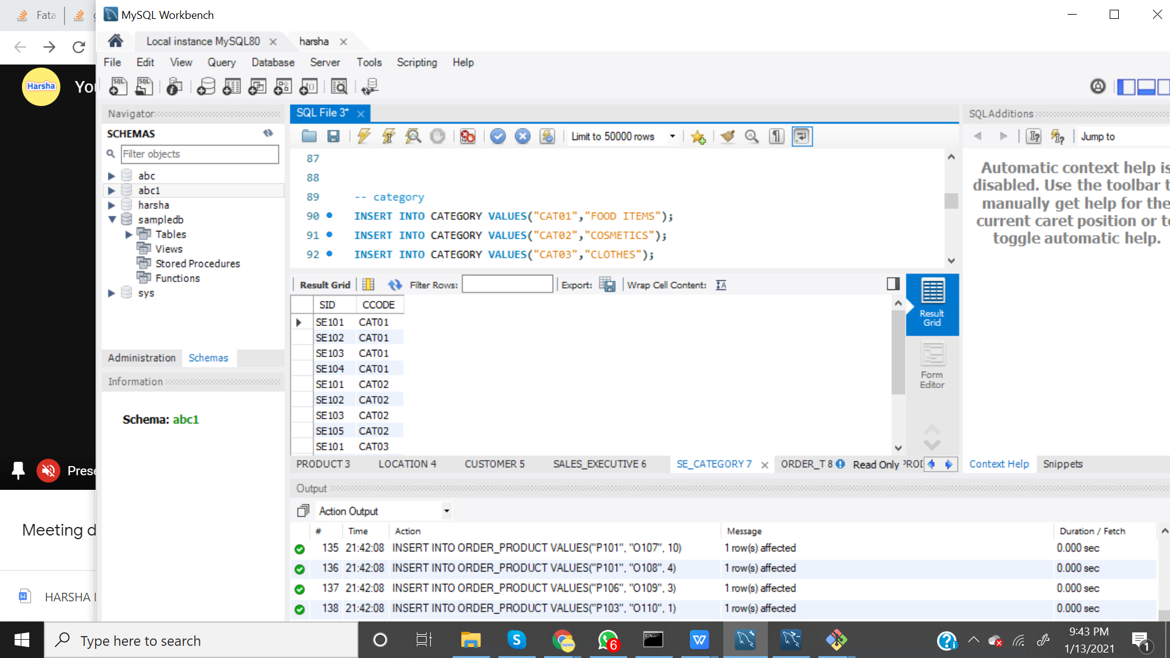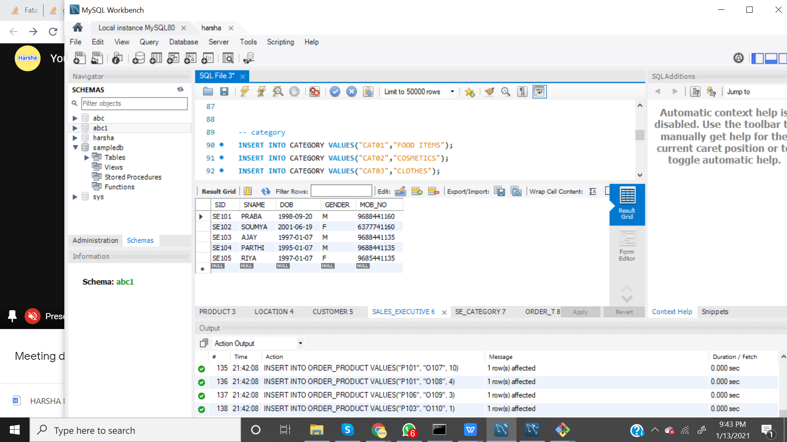

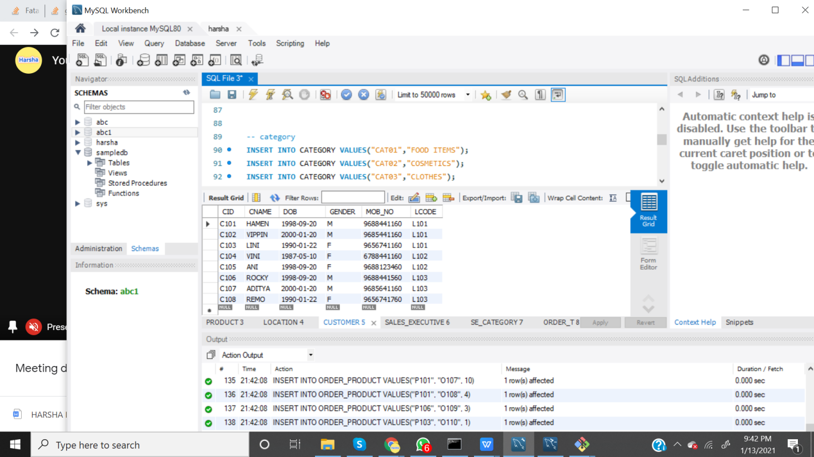

1. **Write a query to retrieve the most sold product per day in a specific location (take any location) in the last week.**
   * Most sold products in a location (Chennai - “L101”) in last week.

**Query:**

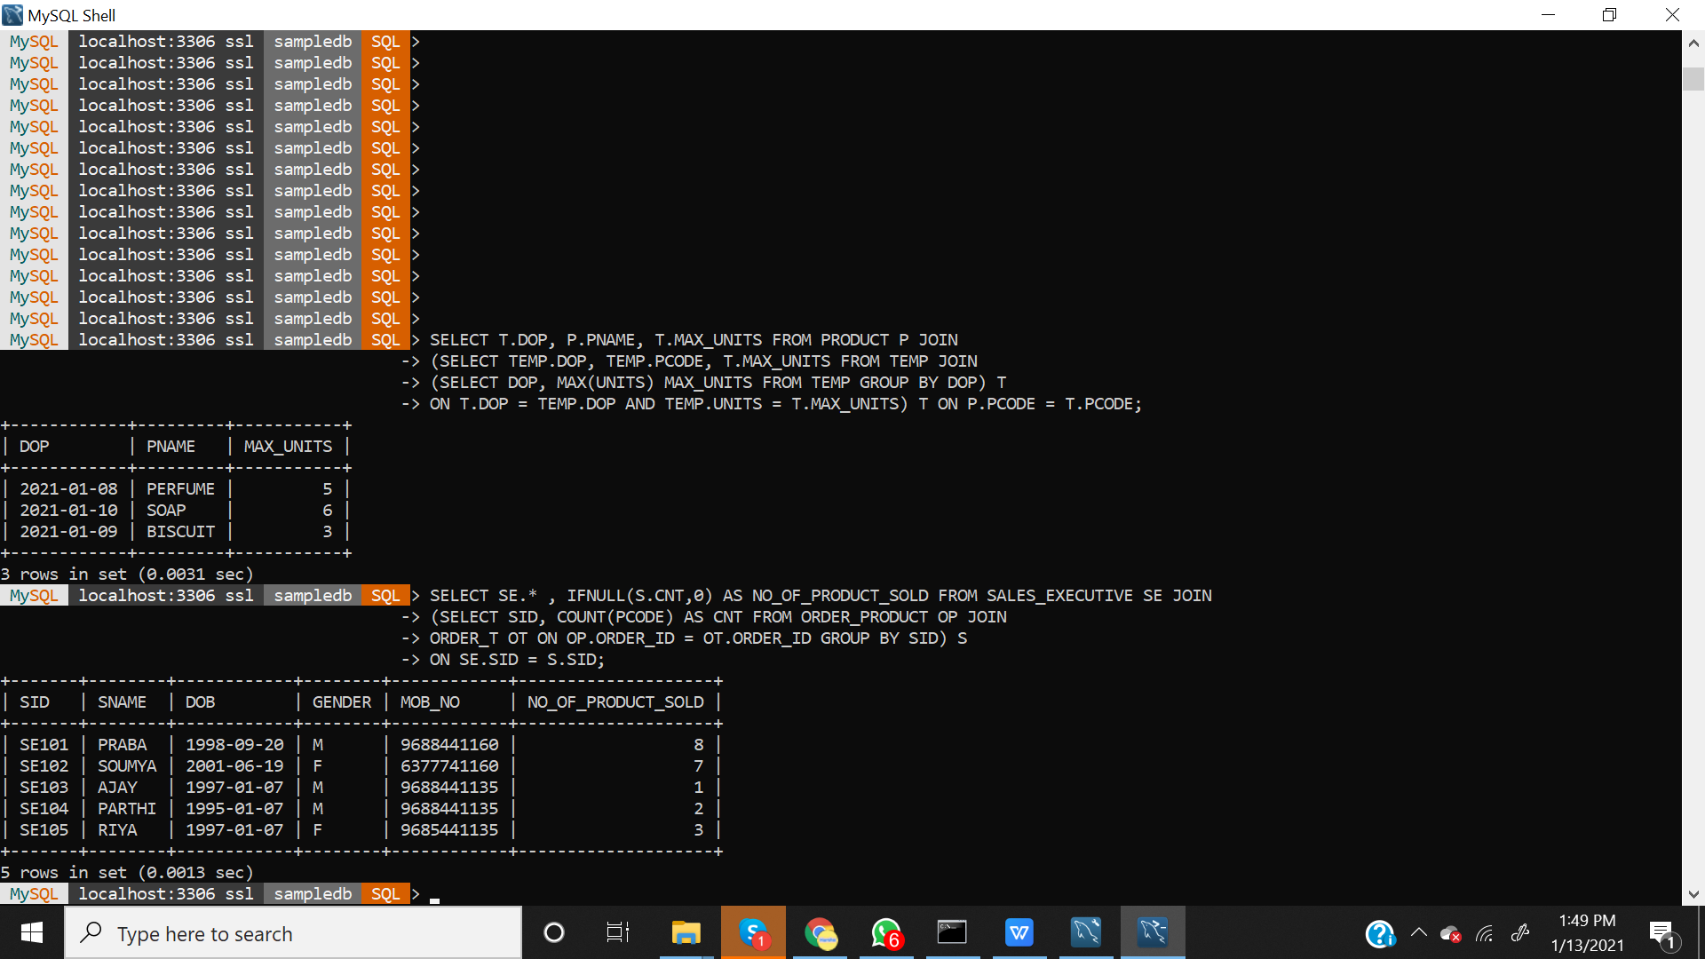

# Write a query to list all the sales persons details along with the count of products sold by them (if any) till current date.

**Query:**



Note: All the queries are in the script file that i have attached.